Software Unit Testing Report

Introduction
This is a report that documents and reflects on developing the "guess the number game" using test-driven development methods and automated unit testing tools. The game is an interactive game where players can guess a randomly generated four-digit number and get clues to guess the result based on the accuracy of the guess. This report outlines the project objectives, requirements, automated unit testing tools used, development process, and lessons I’ve learned from this.
Objectives: Develop a fully functional and interactive "number guessing game" using test-driven development (TDD) principles, and implement automated unit tests to ensure that the code meets the requirements.
Requirements: Randomly generate a four-digit number，then program will keep asking the user to guess the number until the player guesses it correctly or has quitted. When the number is entered, the program will respond with hints，or the player can quit the game anytime once the game is finished.
Automated Unit Testing Tool: For automated unit testing, this project uses the built-in unittest framework in Python.
Process
Test-Driven Development (TDD) Approach:
Test-Driven Development involves three main stages which are (a)writing failing tests; (b)writing minimal code to pass the tests; (c)refining the code keeping pass. 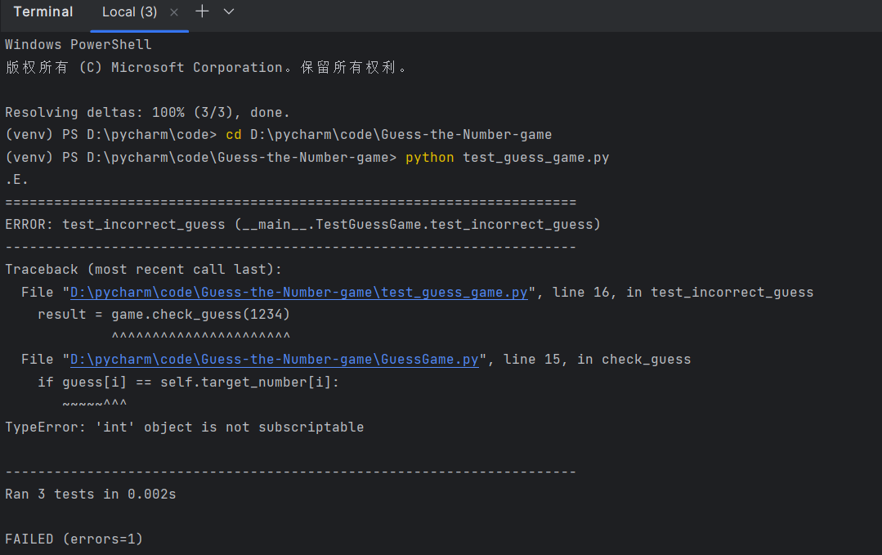
Screenshot of stage(a)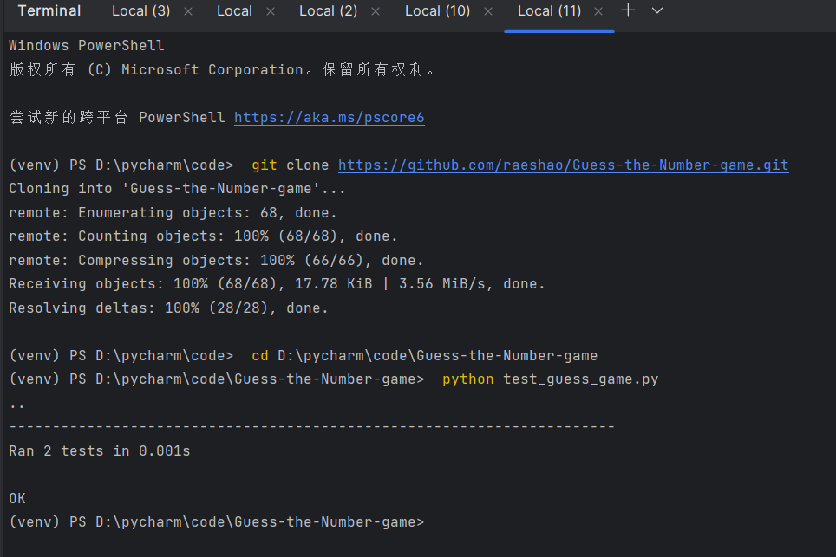
Screenshot of stage(b)
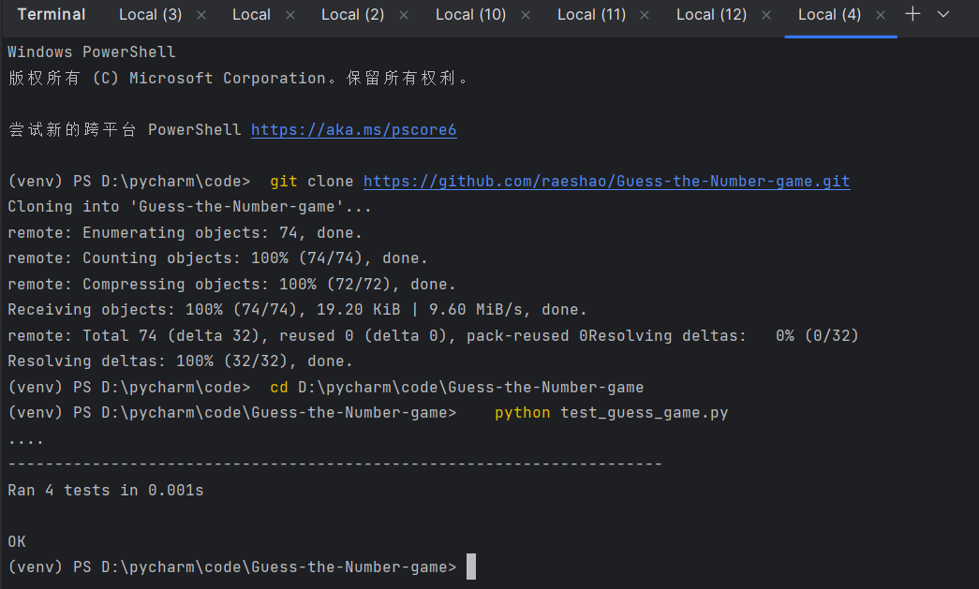
Screenshot of stage(c)

Relevant screenshots for the requirements:
To change important requirements into corresponding test cases. The following screenshots show the results of automated testing for different requirements.

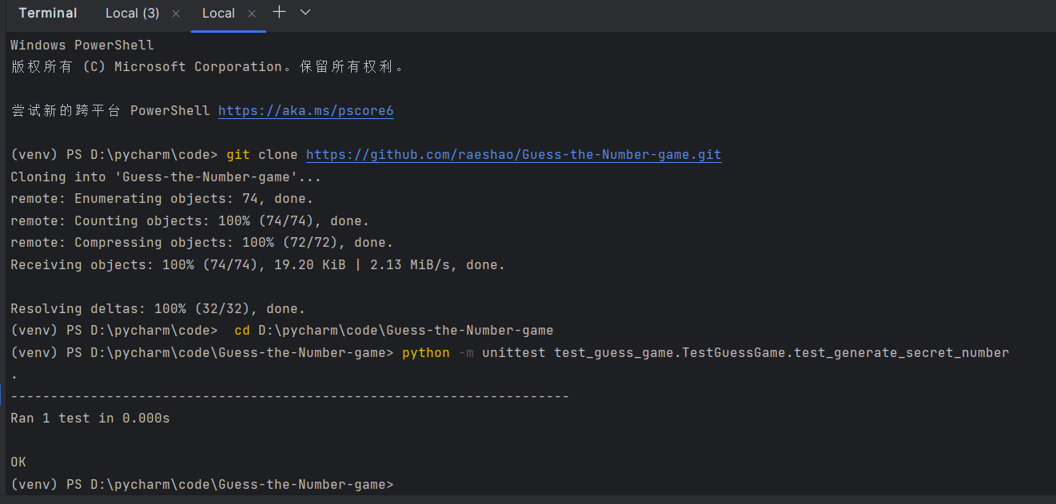screenshot of checking randomly generate a four-digit number

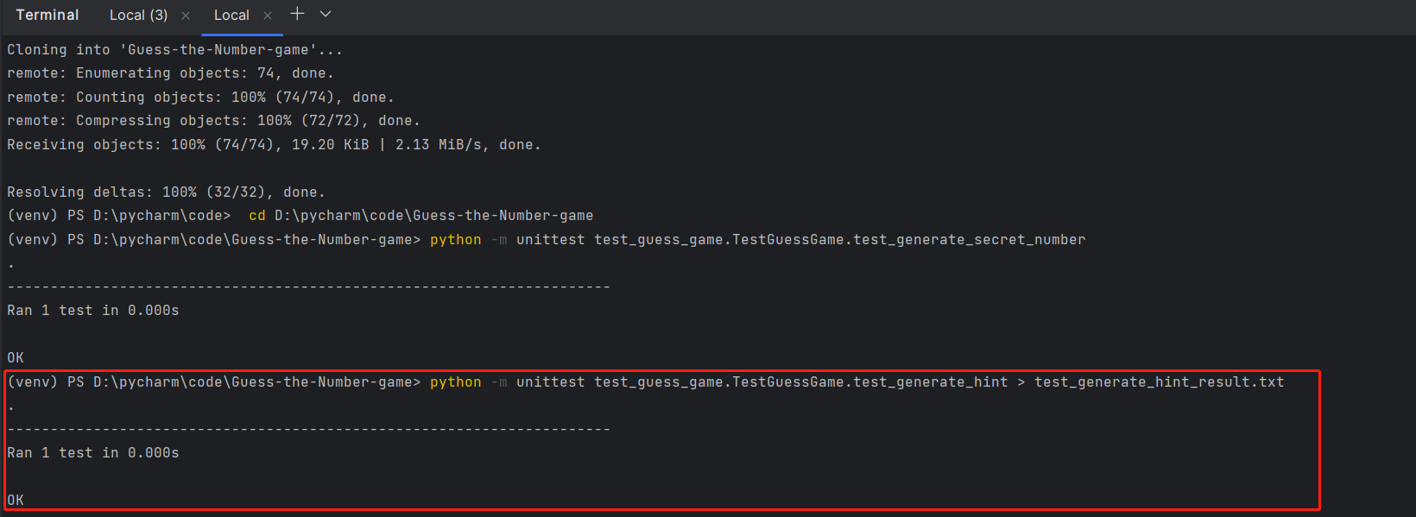
screenshot of checking respond with hints using 'circle' and 'x'

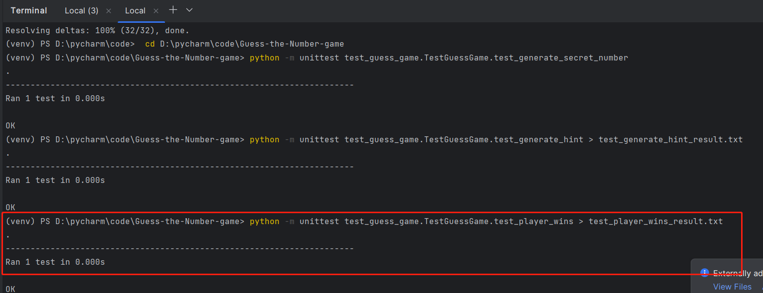
screenshot of checking display the number of attempts taken 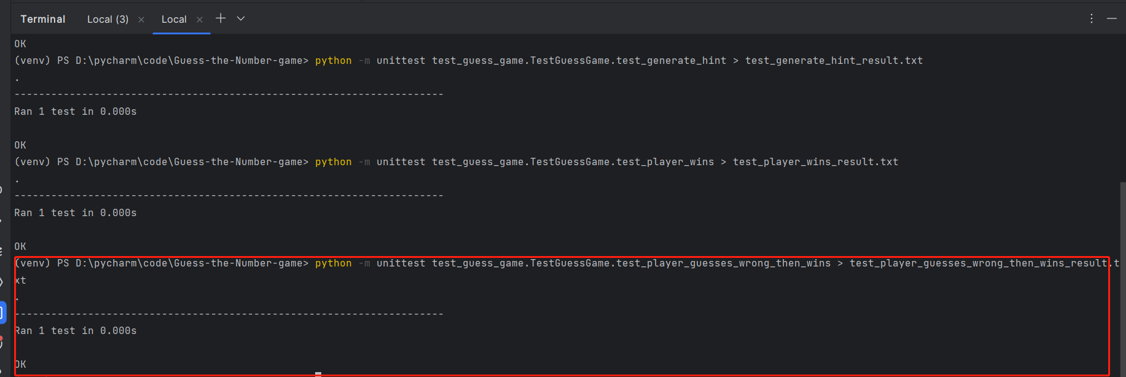
screenshot of checking display the number of attempts when guessing wrong then win

Conclusion
With this assignment, I successfully developed a "guess the number game" using test-driven development and automated unit tests. I feel that the implementation of TDD principles increases the purpose of the code. The use of automated testing also improves the usability of the product. But I should increase the scope of testing to fully ensure the user experience of the product.
.
Github Https: https://github.com/raeshao/Guess-the-Number-game.git

